**Shahzada Nabeel Anjum.**

**18321519-061.**

**BSCS Vi-B.**

**Assignment#04**

**Mobile Application Development**

**Submitted To: Dr.Usman Sb**

**Department Of Computer Science**



**Requirements:**

**Project Name:** Bus Management System

**Editors:** Visual Studio Code , android Studio

**Server:** Xampp Server

**(API) Language:** PHP (server side scripting Language)

**API:** Designed to perform Different Operations.

**Note:**

**In this Assignment Mobile Device is used as a emulator so, instead of localhost, I used 192.168.43.49 in url to access my localhost.**

**API designed in PHP**

**#Connection**

**config.php**

<?php

$conn = mysqli_connect("localhost","root","","rest_api_data") or die("Connection Failed");

 ?>

**api-insert.php**

<?php

header('Content-Type: application/json');

header('Access-Control-Allow-Origin: *');

header('Access-Control-Allow-Methods: POST');

header('Access-Control-Allow-Headers: Access-Control-Allow-Headers,Content-Type, Access-Control-Allow-Methods, Authorization, X-Requested-With');

$bus_no = $_POST['bus_no'];

$driver = $_POST['driver_name'];

$r_from = $_POST['route_from'];

$r_to = $_POST['route_to'];

$seats = $_POST['seats'];

include "config.php";

$sql = "INSERT INTO buses(id,bus_no, driver_name, route_from, route_to, seats) VALUES (NULL, '{$bus_no}', '{$driver}', '{$r_from}', '{$r_to}', '{$seats}')";

if(mysqli_query($conn, $sql)){

print( 'Record Inserted Successfully.');

}

else{

echo 'Record Not Inserted.';

}

?>

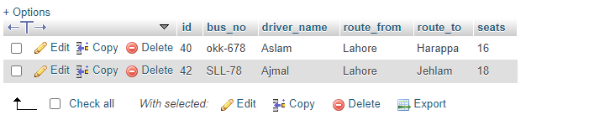

**api-delete.php**

<?php

header('Content-Type: application/json');

header('Access-Control-Allow-Origin: *');

header('Access-Control-Allow-Methods: DELETE');

header('Access-Control-Allow-Headers: Access-Control-Allow-Headers,Content-Type, Access-Control-Allow-Methods, Authorization, X-Requested-With');

$bus_no = $_POST['bus_no'];

include "config.php";

$sql = "DELETE FROM buses WHERE bus_no='{$bus_no}'";

if(mysqli_query($conn, $sql)){

    echo "Record Deleted";

}else{

 echo "Record Not Deleted";

}

?>

**api-update.php**

<?php

header('Content-Type: application/json');

header('Access-Control-Allow-Origin: *');

header('Access-Control-Allow-Methods: PUT');

header('Access-Control-Allow-Headers: Access-Control-Allow-Headers,Content-Type, Access-Control-Allow-Methods, Authorization, X-Requested-With');

$bus_no = $_POST['bus_no'];

$driver = $_POST['driver_name'];

$r_from = $_POST['route_from'];

$r_to = $_POST['route_to'];

$seats = $_POST['seats'];

include "config.php";

$sql = "UPDATE buses SET bus_no='{$bus_no}', driver_name='{$driver}', route_from ='{$r_from}', route_to='{$r_to}', seats='{$seats}' WHERE bus_no='{$bus_no}'";

if(mysqli_query($conn, $sql)){

  echo "Record Updated";

}else{

  echo "Record Not Updated";

}

?>

**Login.php**

<?php

header('Content-Type: application/json');

header('Access-Control-Allow-Origin: *');

header('Access-Control-Allow-Methods:POST');

header('Access-Control-Allow-Headers: Access-Control-Allow-Headers,Content-Type, Access-Control-Allow-Methods, Authorization, X-Requested-With');

$password = $_POST['password'];

$email=  $_POST['email'];

$responsed="";

include "config.php";

$query1= "SELECT * from users where email='{$email}' and pswd='{$password}'";

$raw=mysqli_query($conn,$query1);

$count=mysqli_num_rows($raw);

if($count==1){

    $responsed="Succeed";

}

else{

    $responsed="Denied";

}

echo $responsed;

?>

**Signup.php**

<?php

header('Content-Type: application/json');

header('Access-Control-Allow-Origin: *');

header('Access-Control-Allow-Methods:POST');

header('Access-Control-Allow-Headers: Access-Control-Allow-Headers,Content-Type, Access-Control-Allow-Methods, Authorization, X-Requested-With');

$username = $_POST['username'];

$password = $_POST['password'];

$email=  $_POST['email'];

$responsed="";

include "config.php";

$query1= "SELECT * from users where email='{$email}'";

$raw=mysqli_query($conn,$query1);

$count=mysqli_num_rows($raw);

if($count>0){

    $responsed="Already Exist";

}

else{

$sql = "INSERT into users (id,username,email,pswd) Values (NULL,'{$username}', '{$email}', '{$password}')";

if(mysqli_query($conn, $sql)){

    $responsed="Registered";

}

else

{

 $responsed="Failed";

}

}

echo $responsed;

?>

**NOW GOES TO ANDROID FILES**

**Login.java**

**package** com.example.converter;  
  
**import** androidx.annotation.Nullable;  
**import** androidx.appcompat.app.AppCompatActivity;  
  
**import** android.content.Intent;  
**import** android.os.Bundle;  
**import** android.os.Handler;  
**import** android.view.View;  
**import** android.widget.Button;  
**import** android.widget.EditText;  
**import** android.widget.ImageView;  
**import** android.widget.TextView;  
**import** android.widget.Toast;  
  
**import** com.android.volley.AuthFailureError;  
**import** com.android.volley.Request;  
**import** com.android.volley.RequestQueue;  
**import** com.android.volley.Response;  
**import** com.android.volley.VolleyError;  
**import** com.android.volley.toolbox.StringRequest;  
**import** com.android.volley.toolbox.Volley;  
  
**import** java.util.HashMap;  
**import** java.util.Map;  
  
**public class** login **extends** AppCompatActivity {  
  
 EditText **email**,**pass**;  
 ImageView **img**;  
 TextView **verified**,**signup**;  
 Button **login**;  
 @Override  
 **protected void** onCreate(Bundle savedInstanceState) {  
 **super**.onCreate(savedInstanceState);  
 setContentView(R.layout.***activity_login***);  
  
 **signup**=findViewById(R.id.***signup***);  
 **login**=findViewById(R.id.***login***);  
 **email**=findViewById(R.id.***emaillogin***);  
 **pass**=findViewById(R.id.***passlogin***);  
 **img**=findViewById(R.id.***verify***);  
 **verified**=findViewById(R.id.***verified***);  
  
  
  
  
 **signup**.setOnClickListener(**new** View.OnClickListener() {  
 @Override  
 **public void** onClick(View v) {  
 Intent intent=**new** Intent(getApplicationContext(), register.**class**);  
 startActivity(intent);  
 }  
 });  
  
  
 **login**.setOnClickListener(**new** View.OnClickListener() {  
 @Override  
 **public void** onClick(View v) {  
  
  
 String url = **"http://192.168.43.49/Rest_Api/login.php"**;  
 StringRequest stringRequest = **new** StringRequest(  
 Request.Method.***POST***,  
 url,  
 **new** Response.Listener<String>() {  
 @Override  
 **public void** onResponse(String response) {  
*// Toast.makeText(getApplicationContext(), response.toString(), Toast.LENGTH_LONG).show();* **if** (response.toString().equals(**"Succeed"**)) {  
 **verified**.setText(**"Verified"**);  
 **img**.setImageResource(R.drawable.***ic_verified***);  
 **final** Handler handler = **new** Handler();  
 handler.postDelayed(**new** Runnable() {  
 @Override  
 **public void** run() {  
 Intent intent=**new** Intent(getApplicationContext(), MainActivity.**class**);  
 startActivity(intent);  
 }  
 }, 1500);  
  
 }  
 **else** {  
 **verified**.setText(**"Declined"**);  
 **img**.setImageResource(R.drawable.***ic_not_verified***);  
 }  
  
 }  
 },  
 **new** Response.ErrorListener() {  
 @Override  
 **public void** onErrorResponse(VolleyError error) {  
 Toast.*makeText*(getApplicationContext(), error.toString(), Toast.***LENGTH_LONG***).show();  
 }  
 }  
 ) {  
 @Nullable  
 @Override  
 **protected** Map<String, String> getParams() **throws** AuthFailureError {  
 Map<String, String> params = **new** HashMap<String, String>();  
 params.put(**"email"**, **email**.getText().toString());  
 params.put(**"password"**, **pass**.getText().toString());  
 **return** params;  
 }  
 };  
 RequestQueue requestQueue = Volley.*newRequestQueue*(getApplicationContext());  
 requestQueue.add(stringRequest);  
  
  
  
  
 }  
 });  
  
  
 }  
}

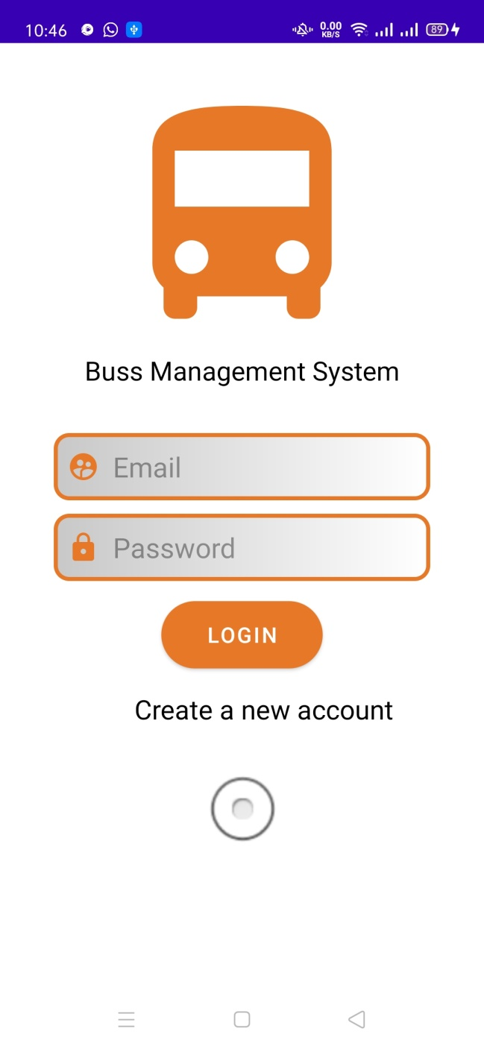

**MainActivity**

**package** com.example.converter;  
  
**import** androidx.appcompat.app.AppCompatActivity;  
  
**import** android.content.Intent;  
**import** android.os.Bundle;  
**import** android.view.View;  
**import** android.widget.AdapterView;  
**import** android.widget.ArrayAdapter;  
**import** android.widget.Button;  
**import** android.widget.EditText;  
**import** android.widget.Spinner;  
  
**public class** MainActivity **extends** AppCompatActivity {  
 Button **insertbtn**,**deletebtn**,**updatebtn**,**RVButton**;  
 EditText **Bus_No**, **Driver_name**,**seat**;  
 String **route_from**, **route_to**;  
 Spinner **spn**,**sp2**;  
 @Override  
 **protected void** onCreate(Bundle savedInstanceState) {  
 **super**.onCreate(savedInstanceState);  
 setContentView(R.layout.***activity_main***);  
  
 **Bus_No** = findViewById(R.id.***bus_no***);  
 **Driver_name** = findViewById(R.id.***driver_name***);  
 **seat**=findViewById(R.id.***seat***);  
 DBHelper dbHelper=**new** DBHelper();  
  
  
 *//Spinners* **spn** = findViewById(R.id.***sp***);  
 String[] R_from = {**"Lahore"**, **"Karachi"**, **"Gujrat"**, **"Sahiwal"**};  
 ArrayAdapter A_Adap = **new** ArrayAdapter<String>(**this**, android.R.layout.***simple_dropdown_item_1line***, R_from);  
 **spn**.setAdapter(A_Adap);  
  
 **spn**.setOnItemSelectedListener(**new** AdapterView.OnItemSelectedListener() {  
 @Override  
 **public void** onItemSelected(AdapterView<?> parent, View view, **int** position, **long** id) {  
 **route_from** = R_from[position];  
  
 }  
  
 @Override  
 **public void** onNothingSelected(AdapterView<?> parent) {  
  
 }  
 });  
  
  
 **sp2** = findViewById(R.id.***sp2***);  
 String[] r_to = {**"Jehlam"**, **"Sialkot"**, **"Multan"**, **"Harappa"**};  
 ArrayAdapter type_Adap = **new** ArrayAdapter<String>(**this**, android.R.layout.***simple_dropdown_item_1line***,r_to);  
 **sp2**.setAdapter(type_Adap);  
  
 **sp2**.setOnItemSelectedListener(**new** AdapterView.OnItemSelectedListener() {  
 @Override  
 **public void** onItemSelected(AdapterView<?> parent, View view, **int** position, **long** id) {  
*// if (sel_type==null && sel_type.isEmpty() && sel_type.equals("null")){* **route_to** = r_to[position];  
*// }* }  
  
 @Override  
 **public void** onNothingSelected(AdapterView<?> parent) {  
  
 }  
 });  
  
  
 **insertbtn**=findViewById(R.id.***insert***);  
 **insertbtn**.setOnClickListener(**new** View.OnClickListener() {@Override  
 **public void** onClick(View v) {  
 dbHelper.insertbus(getApplicationContext(),**Bus_No**.getText().toString(),**Driver_name**.getText().toString(),**route_from**,**route_to**,**seat**.getText().toString());  
 **Bus_No**.setText(**""**);  
 **Driver_name**.setText(**""**);  
 **seat**.setText(**""**);  
 }  
 });  
  
  
 **RVButton**=findViewById(R.id.***RecyclerView***);  
 **RVButton**.setOnClickListener(**new** View.OnClickListener() {  
 @Override  
 **public void** onClick(View v) {  
 Intent i=**new** Intent(getApplicationContext(),RVData.**class**);  
 startActivity(i);  
 }  
 });  
  
  
  
 **deletebtn**=findViewById(R.id.***delete***);  
 **deletebtn**.setOnClickListener(**new** View.OnClickListener() {@Override  
 **public void** onClick(View v) {  
 dbHelper.deletebus(getApplicationContext(),**Bus_No**.getText().toString());  
 }  
 });  
  
  
  
 **updatebtn**=findViewById(R.id.***update***);  
 **updatebtn**.setOnClickListener(**new** View.OnClickListener() {@Override  
 **public void** onClick(View v) {  
 dbHelper.updatebus(getApplicationContext(),**Bus_No**.getText().toString(),**Driver_name**.getText().toString(),**route_from**,**route_to**,**seat**.getText().toString());  
 **Bus_No**.setText(**""**);  
 **Driver_name**.setText(**""**);  
 **seat**.setText(**""**);  
 }  
 });  
  
  
 }  
}

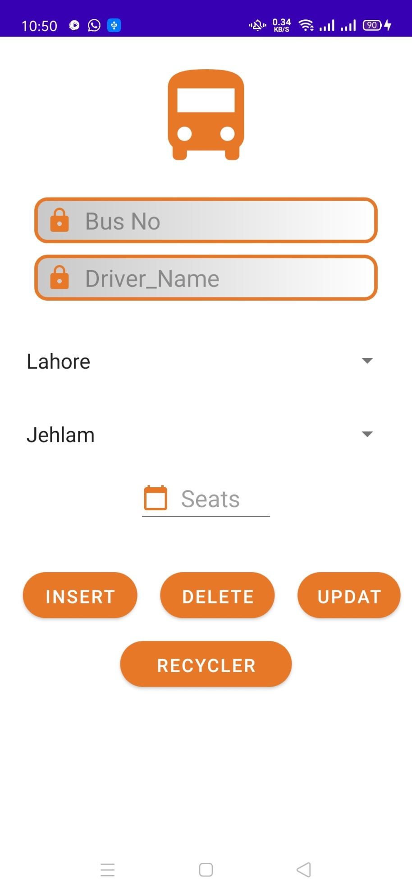

**DBHelper Class**

**package** com.example.converter;  
  
**import** android.content.ContentValues;  
**import** android.content.Context;  
**import** android.database.Cursor;  
**import** android.database.sqlite.SQLiteDatabase;  
**import** android.database.sqlite.SQLiteOpenHelper;  
**import** android.util.Log;  
**import** android.widget.Toast;  
  
**import** androidx.annotation.Nullable;  
**import** androidx.recyclerview.widget.LinearLayoutManager;  
**import** androidx.recyclerview.widget.RecyclerView;  
  
**import** com.android.volley.AuthFailureError;  
**import** com.android.volley.Request;  
**import** com.android.volley.RequestQueue;  
**import** com.android.volley.Response;  
**import** com.android.volley.VolleyError;  
**import** com.android.volley.toolbox.JsonObjectRequest;  
**import** com.android.volley.toolbox.StringRequest;  
**import** com.android.volley.toolbox.Volley;  
**import** com.google.gson.Gson;  
**import** com.google.gson.GsonBuilder;  
  
**import** org.json.JSONException;  
**import** org.json.JSONObject;  
  
**import** java.util.HashMap;  
**import** java.util.Map;  
  
**public class** DBHelper {  
 **public void** insertbus(Context con, String busno, String  
 driver, String route_from, String route_to, String seats) {  
  
 String url = **"http://192.168.43.49/Rest_Api/api-insert.php"**;  
 StringRequest stringRequest = **new** StringRequest(  
 Request.Method.***POST***,  
 url,  
 **new** Response.Listener<String>() {  
 @Override  
 **public void** onResponse(String response) {  
 Toast.*makeText*(con, response.toString(), Toast.***LENGTH_LONG***).show();  
 }  
 },  
 **new** Response.ErrorListener() {  
 @Override  
 **public void** onErrorResponse(VolleyError error) {  
 Toast.*makeText*(con, error.toString(), Toast.***LENGTH_LONG***).show();  
 }  
 }  
 ) {  
 @Nullable  
 @Override  
 **protected** Map<String, String> getParams() **throws** AuthFailureError {  
 Map<String, String> params = **new** HashMap<String, String>();  
 params.put(**"bus_no"**, busno);  
 params.put(**"driver_name"**, driver);  
 params.put(**"route_from"**, route_from);  
 params.put(**"route_to"**, route_to);  
 params.put(**"seats"**, seats);  
 **return** params;  
 }  
 };  
 RequestQueue requestQueue = Volley.*newRequestQueue*(con);  
 requestQueue.add(stringRequest);  
  
 }  
  
  
 **public void** deletebus(Context con, String busno) {  
 String url = **"http://192.168.43.49/Rest_Api/api-delete.php"**;  
 StringRequest stringRequest = **new** StringRequest(  
 Request.Method.***POST***,  
 url,  
 **new** Response.Listener<String>() {  
 @Override  
 **public void** onResponse(String response) {  
 Toast.*makeText*(con, response.toString(), Toast.***LENGTH_LONG***).show();  
 }  
 },  
 **new** Response.ErrorListener() {  
 @Override  
 **public void** onErrorResponse(VolleyError error) {  
 Toast.*makeText*(con, error.toString(), Toast.***LENGTH_LONG***).show();  
 }  
 }  
 ) {  
 @Nullable  
 @Override  
 **protected** Map<String, String> getParams() **throws** AuthFailureError {  
 Map<String, String> params = **new** HashMap<String, String>();  
 params.put(**"bus_no"**, busno);  
 **return** params;  
 }  
 };  
 RequestQueue requestQueue = Volley.*newRequestQueue*(con);  
 requestQueue.add(stringRequest);  
 }  
  
  
 **public void** updatebus(Context con, String busno, String  
 driver, String route_from, String route_to, String seats) {  
  
 String url = **"http://192.168.43.49/Rest_Api/api-update.php"**;  
 StringRequest stringRequest = **new** StringRequest(  
 Request.Method.***POST***,  
 url,  
 **new** Response.Listener<String>() {  
 @Override  
 **public void** onResponse(String response) {  
 Toast.*makeText*(con, response.toString(), Toast.***LENGTH_LONG***).show();  
 }  
 },  
 **new** Response.ErrorListener() {  
 @Override  
 **public void** onErrorResponse(VolleyError error) {  
 Toast.*makeText*(con, error.toString(), Toast.***LENGTH_LONG***).show();  
 }  
 }  
 ) {  
 @Nullable  
 @Override  
 **protected** Map<String, String> getParams() **throws** AuthFailureError {  
 Map<String, String> params = **new** HashMap<String, String>();  
 params.put(**"bus_no"**, busno);  
 params.put(**"driver_name"**, driver);  
 params.put(**"route_from"**, route_from);  
 params.put(**"route_to"**, route_to);  
 params.put(**"seats"**, seats);  
 **return** params;  
 }  
 };  
 RequestQueue requestQueue = Volley.*newRequestQueue*(con);  
 requestQueue.add(stringRequest);  
 }  
  
}

**RVAdapter**

**package** com.example.converter;  
  
**import** android.annotation.SuppressLint;  
**import** android.content.Context;  
**import** android.content.Intent;  
**import** android.util.Log;  
**import** android.view.LayoutInflater;  
**import** android.view.View;  
**import** android.view.ViewGroup;  
**import** android.widget.Button;  
**import** android.widget.EditText;  
**import** android.widget.TextView;  
**import** android.widget.Toast;  
  
**import** androidx.annotation.NonNull;  
**import** androidx.recyclerview.widget.RecyclerView;  
  
**import** java.util.ArrayList;  
**import** java.util.List;  
**public class** RVadapter **extends** RecyclerView.Adapter<RVadapter.RVholder> {  
  
 RecyclerView **recyclerView**;  
 model **data**[];  
  
 **public** RVadapter(model[] data ){  
 **this**.**data**=data;  
 }  
  
 **public** RVadapter() {  
  
 }  
 @NonNull  
 @Override  
 **public** RVholder onCreateViewHolder(@NonNull ViewGroup parent, **int** viewType) {  
  
 Log.*i*(**"check"**, **"onCreateViewHolder: "**);  
 LayoutInflater layoutInflater = LayoutInflater.*from*(parent.getContext());  
 View view = layoutInflater.inflate(R.layout.***model1***,parent,**false**);  
 Log.*i*(**"check"**, **"onCreateViewHolder:2 "**);  
 **return new** RVholder(view);  
 }  
  
 @Override  
 **public void** onBindViewHolder(@NonNull RVholder holder, **int** position) {  
  
 holder.**busNo**.setText(**data**[position].getBus_no());  
 holder.**busModel**.setText(**"Driver: "**+**data**[position].getDriver_name());  
 holder.**comp**.setText(**"From: "**+**data**[position].getRoute_from());  
 holder.**type**.setText(**"To: "**+**data**[position].getRoute_to());  
 holder.**seats**.setText(**"Seats: "**+**data**[position].getSeats());  
 }  
  
 @Override  
 **public int** getItemCount() {  
 **return data**.**length**;  
 }  
  
 **public static class** RVholder **extends** RecyclerView.ViewHolder  
 {  
 TextView **busNo**,**busModel**,**comp**,**type**,**seats**;  
  
 **public** RVholder(@NonNull View itemView) {  
 **super**(itemView);  
 Log.*i*(**"check"**, **"RVholder: "**);  
 **busNo**=((TextView) itemView.findViewById(R.id.***busdisplay***));  
 Log.*i*(**"check"**, **"RVholder: 2"**);  
 **busModel**=((TextView) itemView.findViewById(R.id.***modaldisplay***));  
 **comp**=((TextView) itemView.findViewById(R.id.***company***));  
 **type**=((TextView) itemView.findViewById(R.id.***typedisplay***));  
 **seats**=((TextView) itemView.findViewById(R.id.***seatsdisplay***));  
 }  
 }  
}

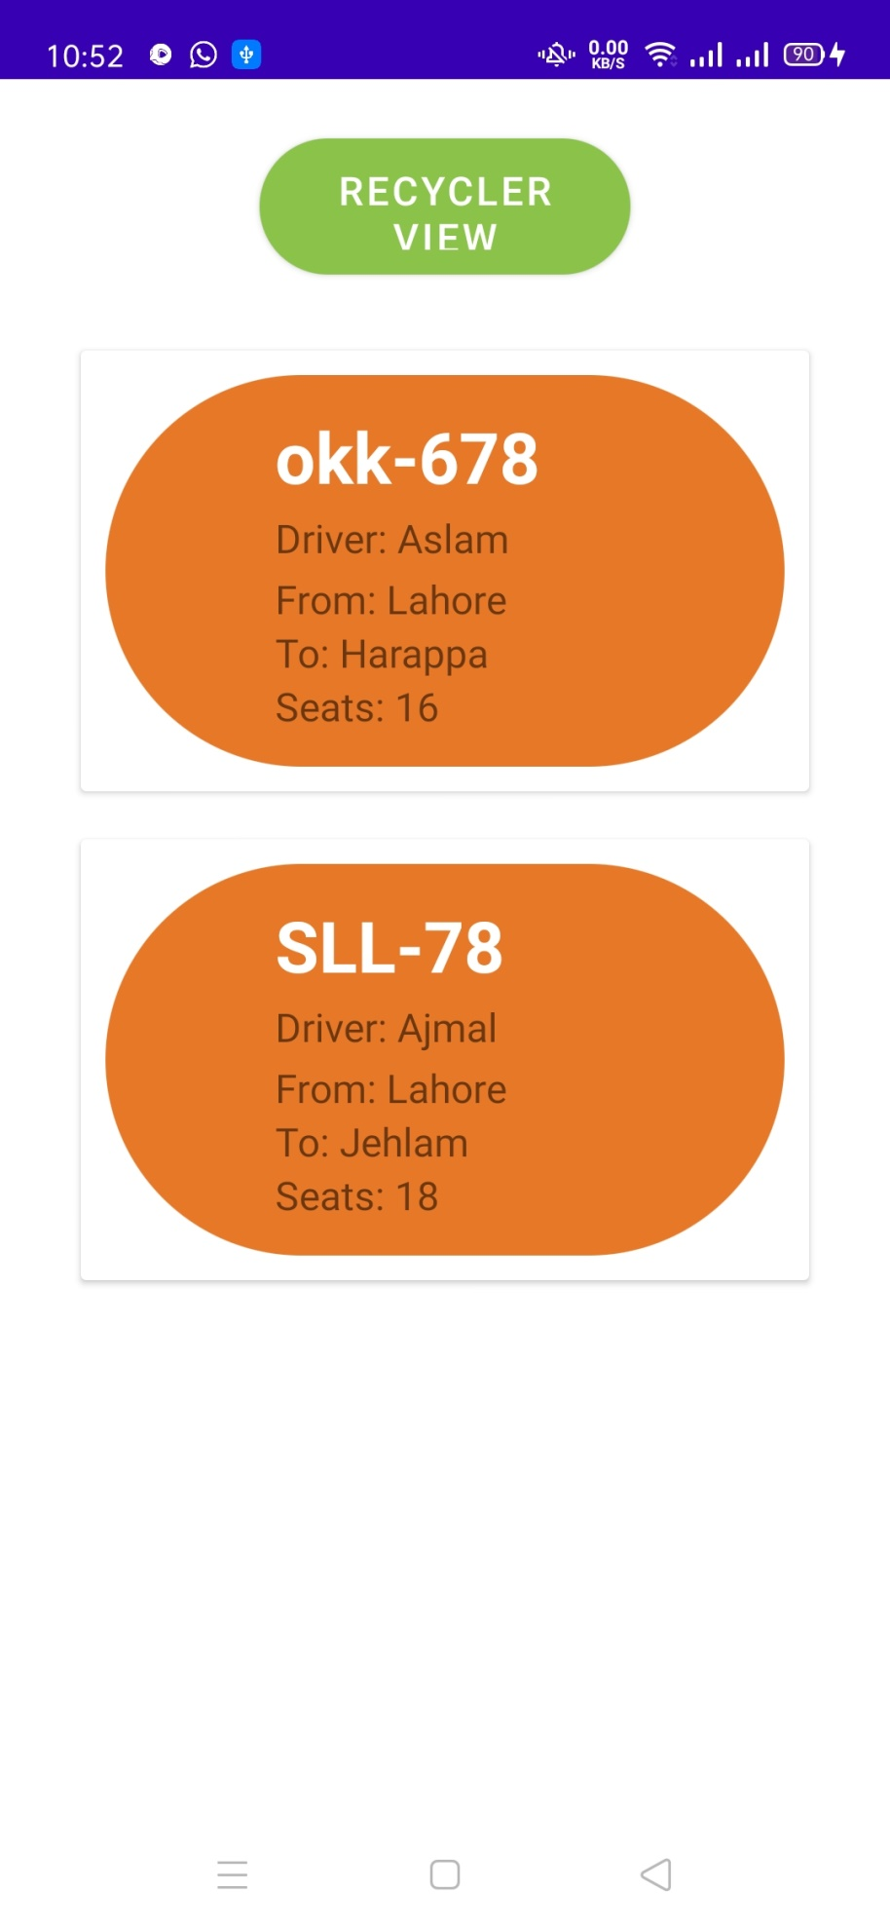

**Activity_login.xml**

*<?***xml version="1.0" encoding="utf-8"***?>*<**RelativeLayout xmlns:android="http://schemas.android.com/apk/res/android"  
 xmlns:app="http://schemas.android.com/apk/res-auto"  
 xmlns:tools="http://schemas.android.com/tools"  
 android:layout_width="match_parent"  
 android:layout_height="match_parent"  
 tools:context=".Login"** >  
  
  
 <**ImageView  
 android:id="@+id/imageView"  
 android:layout_width="200dp"  
 android:layout_height="200dp"  
 android:src="@drawable/ic_bus"  
 android:layout_marginTop="30dp"  
 android:layout_centerHorizontal="true"** />  
 <**TextView  
 android:id="@+id/name"  
 android:layout_width="match_parent"  
 android:layout_height="30dp"  
 android:layout_below="@id/imageView"  
 android:text="Buss Management System"  
 android:layout_centerHorizontal="true"  
 android:textAlignment="center"  
 android:gravity="center_horizontal"  
 android:textSize="17sp"  
 android:textColor="#000"** />  
  
 <**EditText  
 android:id="@+id/emaillogin"  
 android:layout_width="match_parent"  
 android:layout_height="50dp"  
 android:layout_below="@+id/imageView"  
 android:layout_marginLeft="40dp"  
 android:layout_marginTop="60dp"  
 android:layout_marginRight="40dp"  
 android:background="@drawable/modified_button"  
 android:drawableLeft="@drawable/ic_user"  
 android:drawablePadding="10dp"  
 android:hint="Email"  
 android:padding="10dp"** />  
  
 <**EditText  
 android:id="@+id/passlogin"  
 android:layout_width="match_parent"  
 android:layout_height="50dp"  
 android:layout_below="@+id/emaillogin"  
 android:layout_marginLeft="40dp"  
 android:layout_marginTop="10dp"  
 android:layout_marginRight="40dp"  
 android:background="@drawable/modified_button"  
 android:drawableLeft="@drawable/ic_lock"  
 android:drawablePadding="10dp"  
 android:hint="Password"  
 android:padding="10dp"** />  
  
 <**Button  
 android:id="@+id/login"  
 android:layout_width="120dp"  
 android:layout_height="50dp"  
 android:layout_below="@id/passlogin"  
 android:layout_centerHorizontal="true"  
 android:layout_marginTop="15dp"  
 android:background="@drawable/login_button"  
 android:text="Login"  
 android:textColor="#ffff"  
 app:backgroundTint="@color/orange"** />  
  
 <**TextView  
 android:id="@+id/signup"  
 android:layout_below="@id/login"  
 android:layout_marginTop="50px"  
 android:layout_width="250dp"  
 android:layout_height="40dp"  
 android:text="Create a new account"  
 android:textSize="20dp"  
 android:textColor="@color/black"  
 android:layout_marginLeft="100dp"  
 app:srcCompat="@android:drawable/btn_radio"** />  
  
  
 <**ImageView  
 android:id="@+id/verify"  
 android:layout_below="@id/login"  
 android:layout_centerHorizontal="true"  
 android:layout_marginTop="200px"  
 android:layout_width="80dp"  
 android:layout_height="80dp"  
 app:srcCompat="@android:drawable/btn_radio"** />  
  
 <**TextView  
 android:id="@+id/verified"  
 android:layout_width="90dp"  
 android:layout_height="30dp"  
 android:layout_below="@id/verify"  
 android:layout_centerHorizontal="true"  
 android:layout_marginTop="0dp"  
 android:paddingLeft="7dp"  
 android:text=""  
 android:textSize="20dp"**></**TextView**>  
  
</**RelativeLayout**>

**Activity_main.xml**

*<?***xml version="1.0" encoding="utf-8"***?>*<**RelativeLayout xmlns:android="http://schemas.android.com/apk/res/android"  
 xmlns:app="http://schemas.android.com/apk/res-auto"  
 xmlns:tools="http://schemas.android.com/tools"  
 android:layout_width="match_parent"  
 android:layout_height="match_parent"  
 tools:context=".add_form"**>  
  
  
  
 <**ImageView  
 android:id="@+id/img"  
 android:layout_width="100dp"  
 android:layout_height="100dp"  
 android:src="@drawable/ic_bus"  
 android:layout_marginTop="20dp"  
 android:layout_centerHorizontal="true"** >  
  
 </**ImageView**>  
  
 <**EditText  
 android:id="@+id/bus_no"  
 android:layout_below="@id/img"  
 android:layout_width="match_parent"  
 android:layout_height="40dp"  
 android:ems="10"  
 android:hint="Bus No"  
 android:inputType="textPersonName"  
 android:background="@drawable/modified_button"  
 android:layout_marginTop="20dp"  
 android:layout_marginLeft="30dp"  
 android:layout_marginRight="30dp"  
 android:paddingLeft="10dp"  
 android:drawableLeft="@drawable/ic_lock"  
 android:drawablePadding="10dp"** />  
  
  
 <**EditText  
 android:id="@+id/driver_name"  
 android:layout_width="match_parent"  
 android:layout_height="40dp"  
 android:layout_below="@id/bus_no"  
 android:layout_marginLeft="30dp"  
 android:layout_marginTop="10dp"  
 android:layout_marginRight="30dp"  
 android:background="@drawable/modified_button"  
 android:drawableLeft="@drawable/ic_lock"  
 android:drawablePadding="10dp"  
 android:ems="10"  
 android:hint="Driver_Name"  
 android:paddingLeft="10dp"** />  
  
 <**Spinner  
 android:id="@+id/sp"  
 android:layout_below="@id/driver_name"  
 android:layout_width="match_parent"  
 android:layout_height="wrap_content"  
 android:layout_marginTop="20dp"  
 android:layout_marginLeft="30dp"  
 android:layout_centerHorizontal="true"**/>  
  
 <**Spinner  
 android:id="@+id/sp2"  
 android:layout_below="@id/sp"  
 android:autofillHints="Type"  
 android:layout_width="match_parent"  
 android:layout_height="wrap_content"  
 android:layout_marginTop="0dp"  
 android:layout_marginLeft="30dp"  
 android:layout_centerHorizontal="true"**/>  
  
  
 <**EditText  
 android:id="@+id/seat"  
 android:layout_width="120dp"  
 android:layout_height="wrap_content"  
 android:ems="10"  
 android:layout_centerHorizontal="true"  
 android:hint="Seats"  
 android:layout_marginLeft="30dp"  
 android:layout_below="@id/sp2"  
 android:drawableLeft="@drawable/ic_cal"  
 android:drawablePadding="10dp"** />  
  
  
 <**Button  
 android:id="@+id/insert"  
 android:layout_width="100dp"  
 android:layout_height="40dp"  
 android:layout_below="@id/seat"  
 android:layout_marginStart="20dp"  
 android:layout_marginLeft="20dp"  
 android:layout_marginTop="40dp"  
 android:background="@drawable/custom_button"  
 android:text="Insert"  
 app:backgroundTint="@color/orange"** />  
  
 <**Button  
 android:id="@+id/delete"  
 android:layout_width="100dp"  
 android:layout_height="40dp"  
 android:layout_below="@id/seat"  
 android:layout_marginLeft="20dp"  
 android:layout_marginTop="40dp"  
 android:layout_toRightOf="@id/insert"  
 android:background="@drawable/custom_button"  
 android:text="Delete"  
 app:backgroundTint="@color/orange"** />  
  
 <**Button  
 android:id="@+id/update"  
 android:layout_width="90dp"  
 android:layout_height="40dp"  
 android:layout_below="@id/seat"  
 android:layout_centerHorizontal="true"  
 android:layout_marginLeft="20dp"  
 android:layout_marginTop="40dp"  
 android:layout_toRightOf="@id/delete"  
 android:background="@drawable/custom_button"  
 android:text="Update"  
 app:backgroundTint="@color/orange"** />  
  
 <**Button  
 android:id="@+id/RecyclerView"  
 android:layout_below="@id/delete"  
 android:layout_width="150dp"  
 android:layout_height="40dp"  
 android:layout_marginLeft="20dp"  
 android:layout_centerHorizontal="true"  
 android:layout_marginTop="20dp"  
 android:background="@drawable/custom_button"  
 android:text="Recycler View"  
 app:backgroundTint="@color/orange"** />  
  
 *<!-- -->*</**RelativeLayout**>

**Model1.xml**

*<?***xml version="1.0" encoding="utf-8"***?>*<**androidx.cardview.widget.CardView xmlns:android="http://schemas.android.com/apk/res/android"  
 xmlns:app="http://schemas.android.com/apk/res-auto"  
 android:layout_width="match_parent"  
 android:layout_height="wrap_content"  
 android:layout_gravity=""  
 android:layout_margin="5sp"  
 android:elevation="4sp"  
 app:cardCornerRadius="2sp"  
 app:cardUseCompatPadding="true"**>  
  
 <**LinearLayout  
 android:layout_width="match_parent"  
 android:layout_height="wrap_content"  
 android:layout_margin="10dp"  
 android:background="@drawable/custom_button"  
 android:orientation="vertical"  
 android:padding="12sp"**>  
  
 <**TextView  
 android:id="@+id/busdisplay"  
 android:layout_width="300dp"  
 android:layout_height="wrap_content"  
 android:layout_marginLeft="55dp"  
 android:text="Bus No"  
 android:textColor="@color/white"  
 android:textSize="25sp"  
 android:textStyle="bold"** />  
  
 <**TextView  
 android:id="@+id/modaldisplay"  
 android:layout_width="300dp"  
 android:layout_height="wrap_content"  
 android:layout_marginLeft="55dp"  
 android:layout_marginTop="3dp"  
 android:text="Modal No"  
 android:textSize="14sp"** />  
  
 <**TextView  
 android:id="@+id/company"  
 android:layout_width="300dp"  
 android:layout_height="wrap_content"  
 android:layout_marginLeft="55dp"  
 android:layout_marginTop="3dp"  
 android:text="Company"  
 android:textSize="14sp"** />  
  
 <**TextView  
 android:id="@+id/typedisplay"  
 android:layout_width="300dp"  
 android:layout_height="wrap_content"  
 android:layout_marginLeft="55dp"  
 android:text="Type"  
 android:textSize="14sp"** />  
  
 <**TextView  
 android:id="@+id/seatsdisplay"  
 android:layout_width="300dp"  
 android:layout_height="wrap_content"  
 android:layout_marginLeft="55dp"  
 android:text="Seats"  
 android:textSize="14sp"** />  
  
  
 </**LinearLayout**>  
  
</**androidx.cardview.widget.CardView**>

